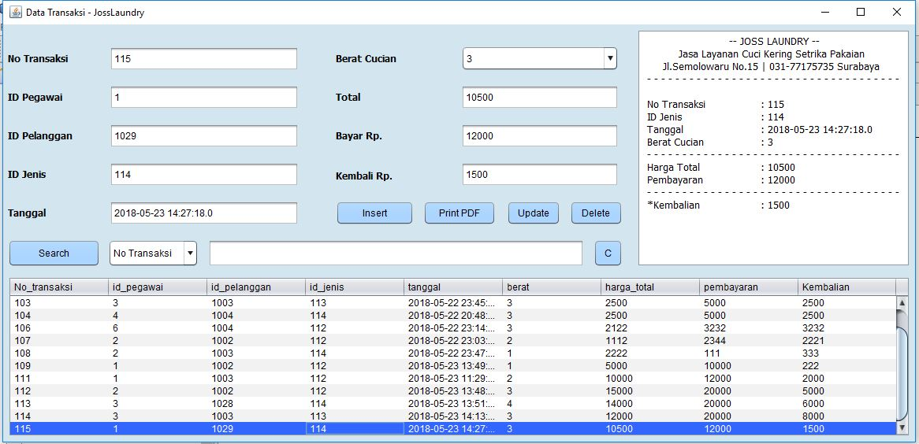

**Insert Data Transaksi :**

private void insertActionPerformed(java.awt.event.ActionEvent evt) {

int kembali = 0;

try {

String sql = "INSERT INTO transaksi VALUES (?,?,?,?,?,?,?,?,?)";

PreparedStatement pst = conn.prepareStatement(sql);

pst.setString(1, txnotransaksi.getText().trim());

pst.setString(2, txidpegawai.getText().trim());

pst.setString(3, txidpelanggan.getText().trim());

pst.setString(4, txidjenis.getText().trim());

pst.setDate(5, new java.sql.Date(System.currentTimeMillis()));

pst.setString(6, cbberat.getSelectedItem().toString());

pst.setString(7, txtotal.getText().trim());

pst.setString(8, txbayar.getText().trim());

kembali = Integer.parseInt(txbayar.getText()) - Integer.parseInt(sumtotal);

pst.setInt(9, kembali);

pst.execute();

tableload(jTable1);

clear();

kodeload(txnotransaksi);

JOptionPane.showMessageDialog(null, "Data Saved");

} catch (Exception ex) {

System.out.println(ex);

JOptionPane.showMessageDialog(null, ex.getMessage());

}

}

**Show Data transaksi Script :**

private void tableload(JTable jt) {

DefaultTableModel dt = (DefaultTableModel) jt.getModel();

dt.setRowCount(0);

try {

ResultSet rset = db.getData("SELECT * FROM transaksi ORDER BY no_transaksi");

while(rset.next()){

Vector v = new Vector();

v.add(rset.getString(1));

v.add(rset.getString(2));

v.add(rset.getString(3));

v.add(rset.getString(4));

v.add(rset.getString(5));

v.add(rset.getString(6));

v.add(rset.getString(7));

v.add(rset.getString(8));

v.add(rset.getString(9));

dt.addRow(v);

}

} catch (Exception ex) {

}

}

**Update tabel Transaksi :**

private void updateActionPerformed(java.awt.event.ActionEvent evt) {

try {

String sql = "UPDATE transaksi SET id_pegawai = "

+ txidpegawai.getText() + ", id_pelanggan = "

+ txidpelanggan.getText() + ", id_jenis = "

+ txidjenis.getText() + ", tanggal = sysdate, berat = "

+ cbberat.getSelectedItem().toString() + ", harga_total = "

+ txtotal.getText() + ", pembayaran = "

+ txbayar.getText() + ", kembalian = "

+ txkembali.getText() + " WHERE no_transaksi = "

+ txnotransaksi.getText();

PreparedStatement pst = conn.prepareStatement(sql);

pst.execute();

clear();

tableload(jTable1);

kodeload(txnotransaksi);

JOptionPane.showMessageDialog(null, "Data Updated");

} catch (Exception ex) {

JOptionPane.showMessageDialog(null, ex.getMessage());

}

}

**Delete Data transaksi Script :**

private void jButton7ActionPerformed(java.awt.event.ActionEvent evt) {

db.putData("DELETE FROM transaksi WHERE no_transaksi = " + txnotransaksi.getText());

clear();

tableload(jTable1);

kodeload(txnotransaksi);

JOptionPane.showMessageDialog(null, "Data Deleted");

}

**Search Data transaksi :**

private void search1(JTable jt2) {

DefaultTableModel dt = (DefaultTableModel) jt2.getModel();

dt.setRowCount(0);

try {

ResultSet rset = db.getData("SELECT * FROM transaksi WHERE no_transaksi LIKE '%" + txsearch.getText() + "%'");

while(rset.next()){

Vector v = new Vector();

v.add(rset.getString(1));

v.add(rset.getString(2));

v.add(rset.getString(3));

v.add(rset.getString(4));

v.add(rset.getString(5));

v.add(rset.getString(6));

v.add(rset.getString(7));

v.add(rset.getString(8));

v.add(rset.getString(9));

dt.addRow(v);

}

}catch (Exception ex) {

}

}

**Cetak PDF Script :**

private void printpdfActionPerformed(java.awt.event.ActionEvent evt) {

try {

// TODO add your handling code here:

Document doc = new Document(PageSize.A4, 150f, 150f, 0f, 0f);

try {

PdfWriter.getInstance(doc, new FileOutputStream("D:\\Education\\FILE KULIAH\\File Belajar Programming\\Programming Java\\Laundry\\Laporan.pdf"));

JOptionPane.showMessageDialog(null, "PDF Successful Saved to : \nD:\\Education\\FILE KULIAH\\File Belajar Programming\\Programming Java\\Laundry");

} catch (DocumentException ex) {

Logger.getLogger(transaksi.class.getName()).log(Level.SEVERE, null, ex);

}

doc.open();

doc.add(new Paragraph(jTextPane1.getText().toString()));

doc.close();

} catch (FileNotFoundException ex) {

Logger.getLogger(transaksi.class.getName()).log(Level.SEVERE, null, ex);

} catch (DocumentException ex) {

Logger.getLogger(transaksi.class.getName()).log(Level.SEVERE, null, ex);

}

}